List of Experiments for Presentations: SIW2 Senses

(n= number of participants, N = number of groups = n/3)

Material:
- n/2 scales 30 cm
- n toothpicks
- Masking tape

Exp 1: Sensitivity of skin (In groups of 3)
1. Organize: Test person, experimenter and recording secretary
2. Prepare recording sheet.
3. Prepare scale: One toothpick at 0 mm firm fixed, second adjustable.
4. Test person is ready to free hand, arm and back.
5. The test person closes his eyes. The experimenter pushes the 2 toothpicks fixed on the scale together against the skin of the palm. Distance of picks first 50 mm. The test person has to tell how many picks he can feel. Recording secretary notes down the answer.
6. Repeat step 5. with distances 40 mm, 30 mm, 20 mm, 10 mm, and 5 mm (randomly chosen). Sometimes in between push only one toothpick against the palm to test the test person’s reliability.
7. Repeat step 5. and 6. on upper arm.
8. Repeat step 5. and 6. on upper back.
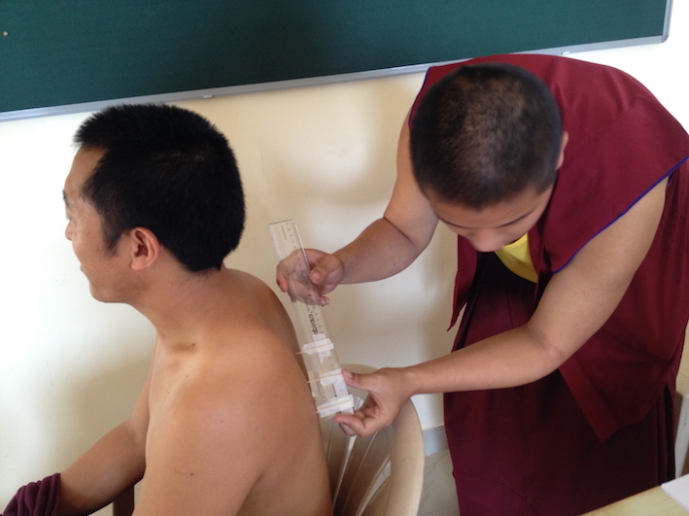

Exp 2: Balance
1. Stand on one foot with eyes open. Observe your body reaction. How easy is it?
2. Stand on one foot with eyes closed. Observe your body reaction. How easy is it?
3. With masking tape mark lines on the flour. Try to walk exactly on the line with open eyes. Observe your body reaction. How easy is it?
4. Try to walk exactly on the line with closed eyes. Observe your body reaction. How easy is it?

Exp 3: Spine (groups of two)
1. Organize: Test person and experimenter
2. The test person stands up, maybe frees the upper body from clothes.
3. The experimenter explores the spine of the test person by touching. Tries to locate the single vertebra.
4. The test person bends forward completely down.
5. The experimenter explores the spine of the test person by touching. Tries to locate the single vertebra. Observation of the difference to step 3.

Exp 4: Knee reflex (groups of two)
1. Organize: Test person and experimenter
2. One person sits on a table and lets his lower legs dangle free and relaxed.
3. Other person hits softly with the edge of one of his hands against the knee just a little below the kneecap.
4. Observe the reaction of the test person’s lower leg.

Exp 5: Reaction, reflex (groups of two)
1. Organize: Test person and experimenter
2. The test person sits relaxed on a chair or on the floor and holds one hand in front of him with stretched thumb and forefinger with a gap of about 4 cm in between.
3. The experimenter holds the scale vertical, so it can fall free between the fingers of the test person. The "0" is exactly at the level of the two fingers.
4. The experimenter lets go the scale and the test person tries to catch it.
5. The test person holds the scale. Determine the number on the scale, where the fingers hold it. Write down the result.
6. Try several times and analyse the data.

