List of Experiments for Presentations: SIW2 Physics Sound

(n= number of participants, N = number of groups = n/3)

1. Vibrations
Material:
- Pointer stick
- Scale 30 cm
- Rubber band over box
- Soft spring
- Ball of Plasticine
- Stand
- 1.5 m String
- Tennis ball
- Drum
- Tuning fork
- Rubber band over box
- Crystal glass (wine glass) with water
- PET Bottles of different sizes + big PET bottle filled with water
- Balloons
- Flute
- Scale on table
- Bell

Demo Exp 1: Introduction vibrations
1. Press with one hand one end of the 30 cm-scale flat and firm on the table. Let overlap half of the scale into free space. With a finger of the other hand pull down the free end approx. 2 cm and let suddenly go. => Vibration => Sound
2. Repeat several times with different length of the free end. => Different pitched
3. Rubber band stretched over a box without cover. Pick the band in the middle and let it go. => Sound
4. Change the tension of the rubber band and repeat step 3.

Demo Exp 2: Spring Pendulum
1. Hang the spring on the stand. On the lower end fix a ball of Plasticine.
2. Let the pendulum oscillate vertically. (Attention: Do not overstretch the spring)
3. Change the mass of the Plasticine. => Observe

Demo Exp 3: Physical Pendulum
1. With masking tape fix on one end of a string a tennis ball or a ball of Plasticine.
2. Hang the pendulum on the stand, so the length of the pendulum can easily be changed. For this put the string over the horizontally mounted iron rod of the stand.
3. Let the pendulum go with different amplitudes. ( -> Measure periods)
4. Change the length of the pendulum. ( -> Measure periods)

Exp 4: Show-jumping course
Sides: Drum
Tuning fork
Rubber band over box
Crystal glass with water (Start vibration with finger)
Bottles to blow
Balloon filled with air, let go out air to make sound
Flute
Scale on table
Bell
Throat (With finger touch softly the throat while singing)
With all instruments try to find out, what mass is vibrating and how the pitch can be changed (Use worksheet)

2. Waves
Material
- Pointer stick
- Very big cover of a large pot from the kitchen (Diameter > 1m
- Bottle of water
- Little pebble (gravel)
- Crumpled piece of paper or wooden piece (size < 1 cm) as wave indicator
- Glass filled with water
- Tuning fork
- Spring Pendulum: Soft spring, Ball of Plasticine, Stand
- A4 paper
- Masking tape
- 4 - 5 m long very flexible rope
- Two 0,5 dl PET bottles
- 1 candle
- Stone-plate or brick
- Matches
- White paper
- Stand
- Drum membrane
- Drumstick from monastery
- Small piece of aluminium foil and sewing thread
- Dry grainy sugar or salt
- Loudspeaker and player (smartphone)
- Two pieces of tiny wooden boards

Demo- Exp 5: Water Waves on Surface
1. Put the pot cover on the floor and fill it with water. -> pond
2. Let fall the pebble in the middle of the pond. => Wave circle
3. Let fall 2 pebbles together in a horizontal distance of approx. 20 cm. => Interference
4. With the top end of a pencil generate waves by moving it up and down in the water in the middle of the pond. => Continuous waves
5. Put a little piece of crumpled paper like a duck in half diameter on the water of the pond and generate waves as in step 4. Observation: Paper stays at the same spot, does not move horizontally with the wave, but moves only vertically

Demo-Exp 6: Tuning fork in water
1. Fill up a glass with water to the edge.
2. Hit a tuning fork and hold it with one "leg" just a little into the water surface.
3. Observe the water surface.

Exp 7: Sine wave drawing
1. Demonstrate again the spring pendulum.
2. Explain, what would happen if the mass would carry a pen and a vertically hold sheet of paper would be moved horizontally to the side and the pen would draw on it.
3. Students prepare N strips of paper: 2 to 3 A4 size papers stick together at the short side with masking tape
3. Three students together imitate the same on the floor as shown in step 2. One student does the movement over the surface of the floor as the pendulum moves up and down in step 2. The other student pulls the paper strip beneath the pen over the floor. => Drawing of sine wave

Demo-Exp 8: Transversal wave with a rope
1. Fix one end of the rope approx. 1 m above the floor on something e.g. like door handle or a student hold it firm.
2. Demonstrator holds the other end firm with one hand, so the rope is quit horizontally and under tension. With the other hand edge he hits the rope approx. 40 cm offside the firm hand. => One crest of wave moves along the rope and comes back as a reflection
3. Repeat step 2. with different tensions on the rope. (=> Crest moves faster, if more tension)
4. Move the other end like a spring pendulum up and down to generate waves.
5. Explain the transversal wave.

Demo-Exp 9: Longitudinal wave with slinky spring
1. Push the pointer stick through the slinky spring and fix one end ring of the slinky spring 10 cm of the end of the pointer stick with masking tape and a peace of wire.
2. Put this end of the pointer stick on the stand, which is on a table.
3. Pull the other end of the slinky spring by expanding the slinky to the other end of the stick. So the slinky lays loose on the stick.
4. Hold the loose end of the slinky with forefinger and thumb and move fast once this end of the slinky in - out approx. 10 cm. => One wave moves along the slinky spring to the fixed and get reflected.
5. Same as step 4, but now move quite fast periodically in - out. => Longitudinal waves
6. At a certain speed of movement: Standing wave are visible.

Demo-Exp 10: Compressibility of air
1. Two 0,5 dl PET bottles, one completely filled with water, one only with air. Close both firm with the screw cup.
2. Lay them on the floor and stand on it. => The air filled bottle is squeezed, the water filled bottle not.

Demo-Exp 11: Sound wave = longitudinal wave 1
1. Fix the drum membrane vertically firm with the stand.
2. Approx. 10 cm in front of the membrane fix a candle, so that the centre line (normal) of the membrane hits the flam. (Candle e.g. on a brick)
3. Lighten the candle.
4. With the drumstick hit the membrane in the centre opposite of candle. => Flame moves fore - back
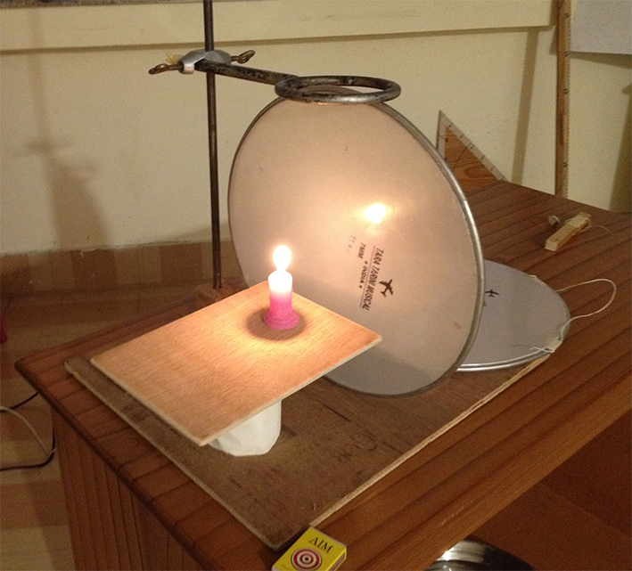

Demo-Exp 12: Sound wave = longitudinal wave 2
Same setting as before
1. Instead of the candle fix a very light little pendulum (mass made of aluminium foil and sewing thread) so that the mass touches very slightly the membrane in the centre.
2. Hold by hand a second drum membrane parallel approx. 30 cm on the opposite side of the little pendulum.
3. Hit this membrane with the drumstick. => Pendulum kicks off
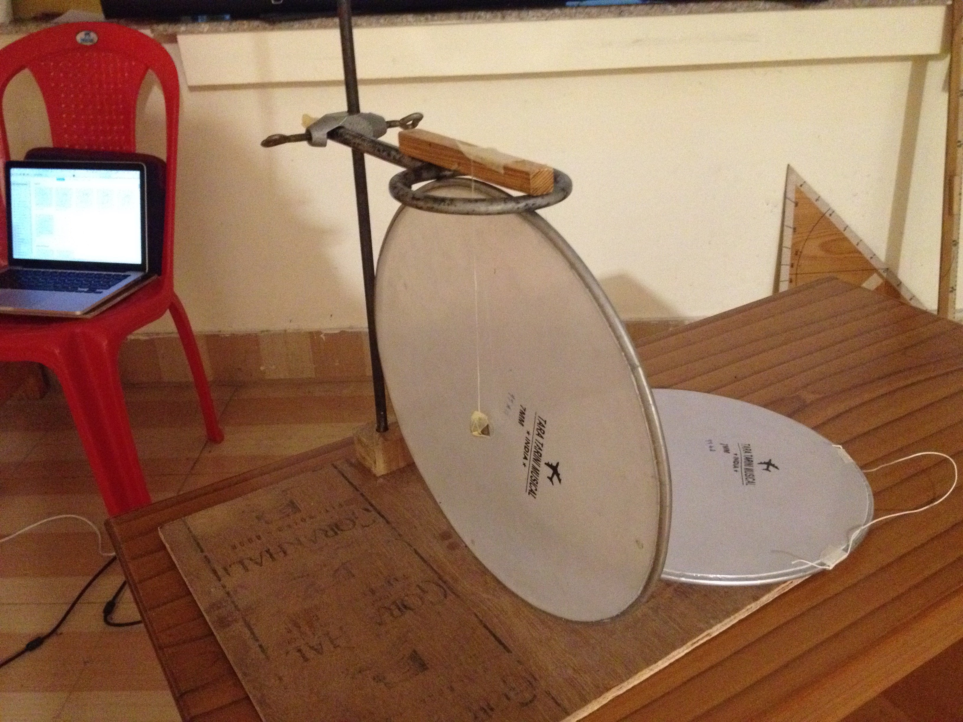

Demo-Exp 13: Dancing sugar
1. Put the drum membrane on e.g. 2 bricks horizontally above the loudspeaker so that the membrane can vibrate freely.
2. With saltshaker or by hand distribute same salt over the membrane.
3. With a smartphone connected to the loudspeaker (Bluetooth) play music of different compositions.
4. Observe the salt on the membrane and how it reacts to different music.
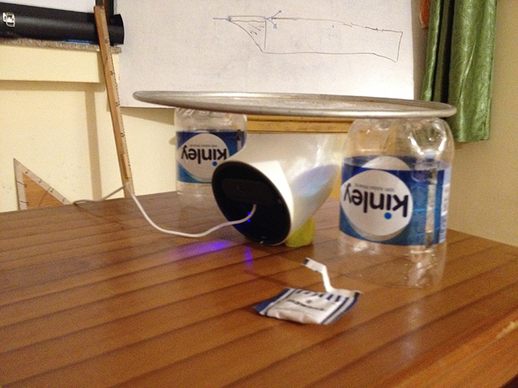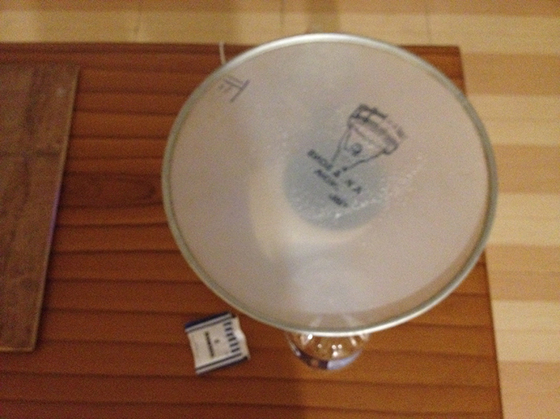

Demo-Exp 14: Speed of sound
1. Send one student with two pieces of tiny wooden boards approx. 150 meters away of the group.
2. He makes a bang by smashing the two boards together.
3. Observe how long it takes for the sound to hear in comparison of "seeing" the bang.

3. Ear
Material
- 2m PVC hose approx. 1 to 1.5 cm diameter
- Hammer or stone
- Computer sound generator app
- Computer sound analyse app
- String phone with plastic cups

Demo-Exp 15: Listen stereo
1. Mark with a felt pen the middle of the hose.
2. Student (listener) holds hose from one ear to the other; hose ends very close to the ear.
3. The loop of the hose lays on a table or the floor.
4. Listener closes his eyes.
5. Another student hits smoothly with the hammer or a stone first in the middle of the hose, then on different positions at left or right of the middle. The listener has to show with his hand from which direction he hears the sound.

Exp 16: String phone
1. Prepare several string phones with plastic cups and string.
2. Let the students play with it.

Demo-Exp 17: Analyse sound of vowels etc.
1. Use computer with sound analyse app and sound generator of a smartphone to show the waveforms of what we hear.
2. Use computer with sound analysis app and voice of vocalist to show the wave form of vowels.

