List of Experiments for Presentations: SIW1 Chemistry

(n= number of participants, N = number of groups = n/3)

1. Introduction Chemistry
Material:
- Spoons, forks made of plastic and metal
- Transparent glass cup filled with drinking water
- Sugar, salt
- Iron nail
- Bunsen burner + matches
- Gas cylinder
- Stone plate
- Laboratory pliers
- Chocolate
- Biscuits (sweet)
- Water heater
- Big bowl
- 2 small bowls
- Stand
- Ev. Pyrex glass
- Ice cubes
- Electronic thermometer
- Magnesium ribbon
- Steel wool
- Beam balance
- Fine iron wire 2 pieces 10 cm to fix Fe-wool

Demo Exp 1: Form - Material
1. Show: Spoons, forks made of plastic and metal.
2. Ask for what is same, what is different (form - material).

Demo Exp 2: Dissolving
1. Put sugar or salt into drinking water.
2. Taste the water.
3. Boil the sugar-water to evaporate water.
4. Observe what is left and taste it.

Demo Exp 3: Glowing Nail
1. Start burner with much air (hot flam).
2. Hold an iron nail kept with laboratory pliers into the flame.
3. Observe.
4. Cold: It is still iron.

Exp 4: Melt chocolate 1
1. Distribute pieces of chocolate to each student.
2. Students take it into the mouth on the tongue and no chewing.
3. Students observe what happens with the solid chocolate piece.

Demo Exp 5: Melt chocolate 2
1. Boil water.
2. Drain the hot water into the big pan.
3. Put chocolate pieces in the small bowl + ev. little water to make better contact.
4. Observe -> melting
5. Distribute biscuits -> eat

Demo Exp (optional) 6: Melt ice
1. Prepare stand and burner to heat a Pyrex glass.
2. Put ice-cubes in a small bowl or Pyrex glass.
3. Heat it and measure temperature.
4. Observe the temperature -> conclusion

Demo Exp 7: Burn Magnesium (Mg)
1. Prepare burner on stone plate.
2. Cut a piece of magnesium.
3. Give it to students for inquiring.
4. Hold Mg with laboratory pliers into the flame (Attention protect eyes).
5. As soon as it catches fire remove from the flame, hold it above the stone plate.
6. Show left over to the students.
7. Conclusion: Transformation = chemical reaction

Demo Exp 8: Burn steel wool (Fe)
1. Fix beam balance on stand.
2. Fix on both ends same quantity of Fe-wool (equilibrium).
3. Stone plate below the side, where it will combust.
4. Set fire to the Fe-wool.
5. Observe
6. Conclusion: matter disappeared
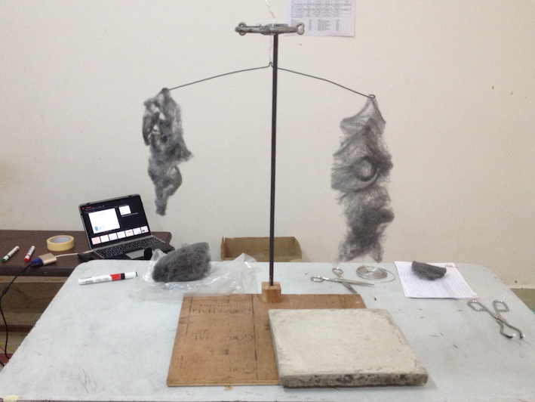

2. Chemistry of Burning Candles
Material:
- N candles
- N matchboxes
- N small carton plates
- 2∗N candles
- N Steel meshes
- N clothes-pegs
- N glass tubes 7 cm long
- Magnifier
- Stand with funnel mounted upside down connected to hose
- Limewater (has to be prepared 2 days ago by solving Ca(OH)₂ in Dest-Water
- Test tube
- Drinking straw
- Brick
- Glass
- Toilet paper
- N tea candles
- N drinking glasses
- N small plates, water-resistant

Exp 9: Burning process of a candle
1. Take a piece of wax and hold it in hands.
2. Observation: Wax gets smooth or even liquid.
3. Observe the wick of the candle with magnifier.
4. Conclusion: Effect like vessels - capillarity possible.
5. Light candle.
6. Observe: Where solid - liquid? Why is there a higher edge and the liquid does not go out?
7. With finger feel the temperature at different positions.
8. Observe: Where is it hotter? If calm air is around the flame, why has the flame this form?
9. Ev. by teacher: Hold a small sheet of paper without movement for 2 seconds horizontally into the flame just above the end of the wick.
10. Interpret what you see on the paper -> beside smut a brown ring burned into the paper. Conclusion: Heat in the middle of the flame is much lower.
11. Blow of candle and quickly observe the wick -> Capillarity active
12. Light candle.
13. With clothes peg hold steel mesh over the flame, lower into the flame.
14. Observe: a) If mesh in the flame->no flam3 above, but a lot of smoke. Which colour?
b) Mesh gets sooty. Why?
15. Light both candles, hold steel mesh into the flame, hold second flame into smoke.
16. Observe: flame chokes. Why? (CO2 but no O2)
17. One candle burning, blow it out.
18. Observe: White "smoke"
17. Light both candle, blow off one and bring the wick of the blown off candle into the white smoke.
18. Observation: Flame jumps over. Why?
19. Light one candle; hold glass tube with clothes peg tilted in it at
a) the flame base.
b) the flame top (yellow part).
20. Observation: a) white smoke, b) black smoke
21. Light both candles; hold tilted glass tube with clothes-peg into the flame base.
Hold second flam at top end of the glass tube.
22. Observation: A flame burns at the end of the glass tube.
23. Conclusion: Gas is burning -> gas is produced if there is enough heat.
24. Put three layers of wet toilet paper (seal) into the carton plate. Put a small candle into the centre and light it. Put upside down a drinking glass over the candle. Be aware, that no air can enter into the glass volume.
25. Observation: After a short time the flame extinguishes -> no more Oxygen

Demo Exp 10: CO₂ detection
1. Explain what is limewater.
2. Put some limewater into a test tube.
3. Hold breath for at least one minute.
4. Blow the exhaust with straw into the limewater -> turns milky
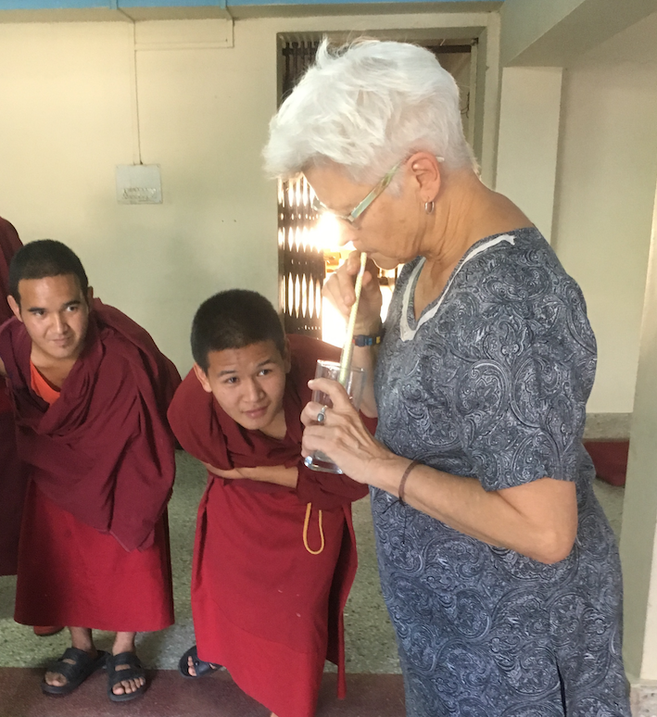

Demo Exp 11: CO₂ detection from burning candle
1. Put candle below the funnel on the stand.
2. Put test tube with limewater into a glass to hold it.
3. Put glass with test tube with limewater on a brick.
4. Light candle.
6. After 30 seconds put open end of the hose a little bit into the limewater.
7. Wait few minutes and observe -> Limewater turns milky
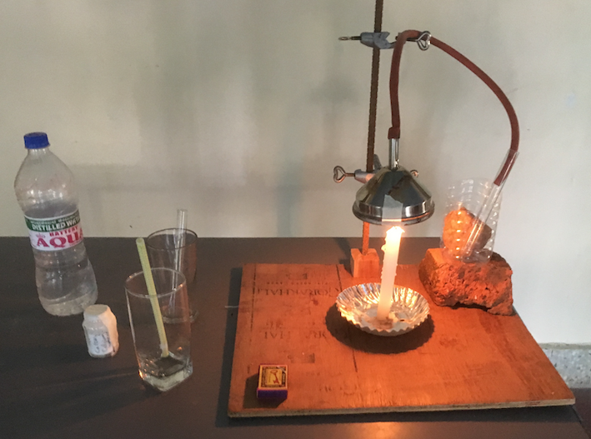

3. Climate Change
Material:
- 2 temperature sensors and computer with program "Logger Light App"
- 2 Coke glass bottles, one covered with soot one with aluminium foil, filled with water
- 2 identically formed thermofoam boxes
- Masking tape
- Aluminium foil A4 size
- Candle + matches
- 1 Plexiglass to cover

Demo Exp 12: Absorption of Heat
1. Prepare 2 identical Coke glass bottles; one covered with soot by holding the bottle into the flame of a burning candle, the other covered with aluminium foil.
2. Fill in both bottles exactly the same quantity of water.
3. Set up the computer with the program "Logger Light App" and 2 temperature sensors.
4. Expose bottles with senores to the sun and run the program for 60 minutes.
5. Analyse the two temperature-time graphs.
6. Observation: Black bottle gets much warmer.
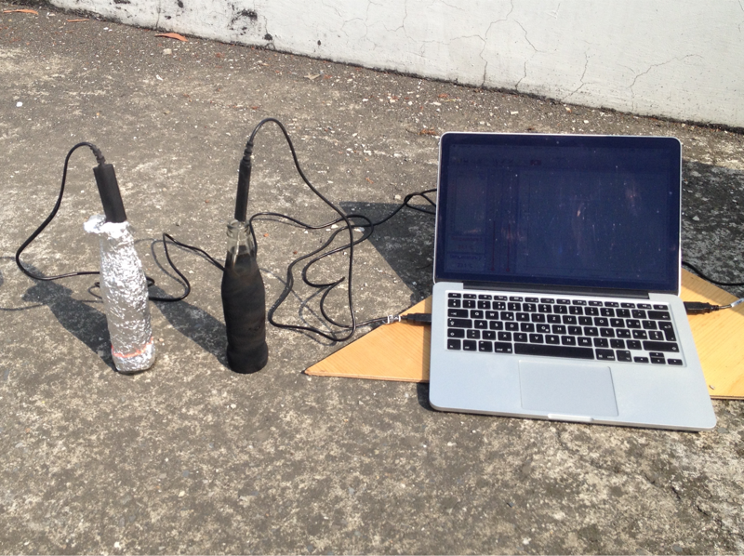

Demo Exp 13: Greenhouse-Effect
1. Form 2 identical open boxes from thermofoam approx. size: 50cm x 30cm x 20cm using masking tape.
2. One box with thermofoam cover, one box with plexy glass cover.
3. Through a little hole on a sidewall of each box insert the temperature sensors into both boxes.
4. Set up the computer with the program "Logger Light App" and 2 temperature sensors.
5. Expose both boxes to the sun and run the program for 45 minutes.
6. Analyse the two temperature-time graphs.
