List of Experiments for Presentations: SIW2 Physics Optics

(n= number of participants, N = number of groups = n/3)

1. Repetition Physics SIW1
Material:
- Pointer stick
- Candle + matches + stone-plate
- Red laser
- Big mirror (Size A5)
- Incense sticks

Demo Exp 1: Beam of Light, Reflection
1. With the flame of a burning candle on a stone plate lighten a bunch of incense sticks.
2. Use the smoke of incense sticks and bring the smoke into the LASER beam.
3. Demonstrate reflection on mirror with laser and smoke (different angles etc.).

2. Refraction
Material
- Torch
- Candle
- Stone-plate
- Incense sticks
- Matches
- White paper
- Laser + mirror
- Glass filled with water
- Spoon
- 2.5.litter PET bottle part of side cut out filled with water,
- Little mirror
- 2 small logs of wood
- Few drops of milk
- Stand with prism

Exp 2: Intro Refraction
1. Put a spoon in a glass of water may be several sets.
2. Give the glasses to the students.
3. Ask what they can observe.

Demo- Exp 3: Refraction at water surface
1. Cut out part of side of a 2.5-litter PET bottle. Screw cover left on the bottle.
2. Lay down the bottle and fix it with wooden logs, so it cannot roll off.
3. Put small mirror in the middle down into the bottle and the cut out part is on top.
4. Fill it with water.
5. Add 1 ev. 2 drops of milk and stir with a spoon.
6. Use the smoke of incense sticks and bring the smoke into the LASER ray close to the water surface.
7. Let the LASER ray hit the water surface with different angles. Indicate the ray with smoke.
8. Observe incoming and refracted ray in the milky water in relation to mirror and the reflection on the mirror in the water.
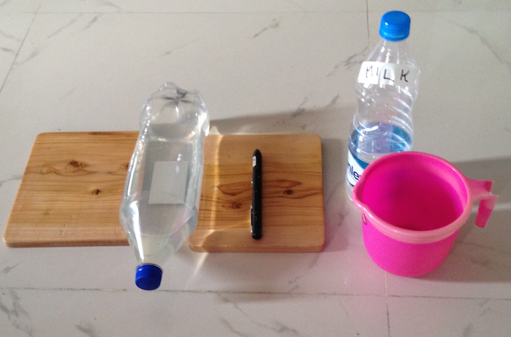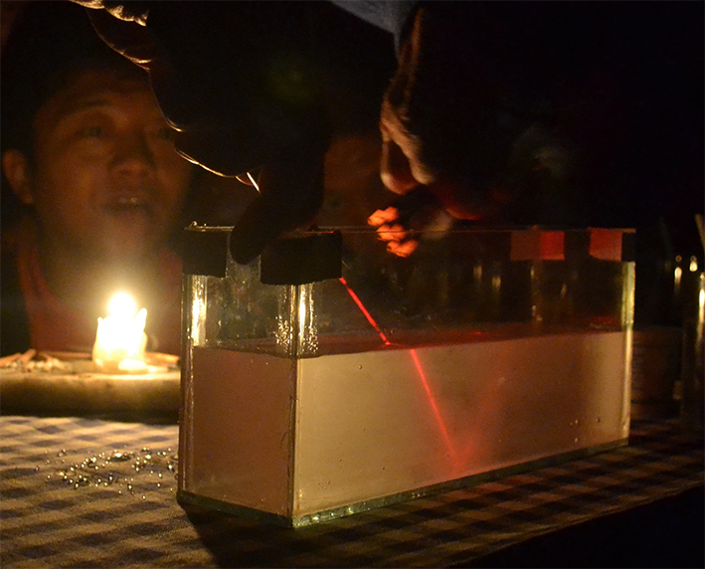

Demo-Exp 4: Animation with App
Phet: bending-light_bo.html

Demo-Exp 5: Refraction at prism
1. Fix the prism high up on the stand.
2. Use the smoke of incense sticks and bring the smoke into the LASER ray close to prism surface.
3. Let the LASER ray hit the prism surface with different angles. Indicate the ray with smoke.

3. Pin Hole Camera
Material
- Pin hole camera, prepared with different holes
- Stand with one electro spot lamp/candle
- Matches
- Transformer
- 1 lens (Magnifiers)

Demo-Exp 6: Pin hole camera
1. Put the stand on a chair and fix a electric spot lamp on the stand high up.
2. Darken the room as much as possible.
3. Hold the camera with big hole mounted in front of the switched on electric spot lamp. Move the camera forth and back and observe the image in the screen of the camera (Lamp very fuzzy visible).
4. The same with different size of the hole (Smaller holes -> sharper image).
6. The same with F-shaped object in front of spot lamp.
5. The same with burning candle on stand.
6. The same with burning candle on stand with magnifier lens instead of hole.
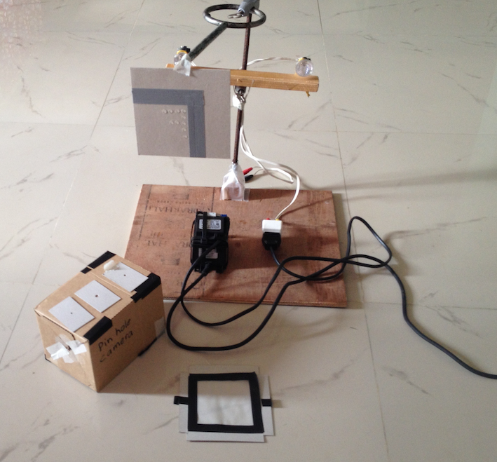

Exp 7: Sun images under a tree
If there is sunshine go outside under a fare-covered tree, so you can see small spots of light under the tree on the ground in the shadow of the tree. (These are images of the sun (many round circle shaped spots).
Pin hole camera: Sun under trees -> many circles

4. Lens
Material:
- N lenses (Magnifiers) for students
- N candles
- N carton plate
- N match-boxes
- White paper
- Masking tape

Exp 8: Focus point
1. Go outside in the sun.
2. Find focus point with the magnifier-lens on a white paper.
3. Measure distance from lens to screen (white paper).

Exp 9: Burn paper
Focus with sunlight on newspaper -> burning. It may work better, if the focus point is on a black printed area of the newspaper.

Exp 10: Image of candle in groups of 2 or 3
1. Fix the white paper vertically to the wall close to the floor as a screen.
2. Put the lens box upside down on the floor and on top the lens in vertical position.
3. Put the candle on a carton opposite the screen, so that screen, lens and candle are more or less lined up.
4. Move the lens forward and backward until a sharp image appears.
5. Measure distance candle-lens and lens-screen and write it down into the worksheet.
6. Repeat several times with different distances candle - screen.

Optional Experiments:
- Total Reflection
- Optical fibre
- Horizontal water jet from little hole at bottom of 2.5 L bottle with LASER

Eye
Material:
- n pencils
- N torchlights
- n anaglyph eyeglasses
- 2*N magnifier
- N holder-plate
- N stereo photos
- Masking tape
- VR glasses and smartphone with stereo movie

Exp 11: Reflex of pupil in groups of 2, stay in dark room
1. Observe the eye of your partner.
2. Suddenly flash with light on the eye.
3. Look for the reaction.
4. Wait for few minutes.
5. Look to the pupil of your partner first in the dark. How big is the pupil?
6. The same but eye with torchlight lighted.

Exp 12: Distant seeing
1. Stand outside, where you can see an object several 100 meters away.
2. Hold with stretched arm the pencil vertical with point on top in front of eyes.
3. Change focus to pencil and then to object and back again etc.
4. Observe the sharpness of the surrounding.

Exp 13: Field of Vision
1. Hold with stretched right arm the pencil vertical with point on top in front of eyes.
2. Do not move the head neither the eyes. Move the pencil to the right until you cannot. see it anymore. Observe how far you can move.
3. Do the same with the left arm to the left. Observe how far you can move.

Exp 14: Stereoscopic Vision
1. Stand outside, where you can see an object several 100 meters away.
2. Hold with stretched arm the pencil vertical with point on top in front of eyes.
3. Close left eye and observe the environment in relation to the pencil with right eye only.
4. Without moving the head and pencil close the right eye and open the left.
5. Repeat changing the open eye several times left-right-left.
6. Observe the position of the pencil in relation to the environment each time (pencil jumps).

Exp 15: Stereoscopic Vision with anaglyph eyeglasses
1. Look at projected pictures. Observe what you see.
2. Put on anaglyph eyeglasses. Observe now again.

Exp 16: Stereoscopic Vision Stereoscope
1. Fix with masking tape two lenses of magnifier on the holder-plate.
2. Hold the holder with lenses approx. 10 cm above the stereo-pictures.
3. Look at the picture.

Demo-Exp 17: Stereo Movie
1. Make VR Glasses ready.
2. Insert smartphone with a stereo movie started.
3. Watch the movie.

