List of Experiments for Presentations: SIW1 Intro + Climate Change

1. Why is Western Science education important for Buddhist nuns and monks?
Material:
- Pointer stick
- Candle
- Matches
- Stone-plate
- Matches
- Plain A4 paper
- Ev. Plant in pot
- Inflatable globe (to show Switzerland)

Demo-Exp 1: Physics <-> Chemistry <-> Biology:
1. Paper, through, tear, crumble etc. This is physics: No transformation of matter
2. Over stone plate burn the paper => new matter
3. Show plant and touch it. You feel the life.

2. History of Science
Material:
- Pointer stick
- 1 m sting
- Masking tape
- Roll toilet paper
- Plain A4 paper
- Piece of wire
- Wash bottle (3 or 5 dl PET bottle with short PVC hose fixed through the cover)
- Ink
- Water heater
- Pan
- Bucket with cold clean water
- Model Chain, pulley, door
- Inflatable globe
- 2 pointer sticks, plasticine, tape
- Tennis ball ev. stone
- Tennis ball
- Paper airplane

Demo-Exp 2: Wash bottle (Air needs space)
1. Show empty PET wash bottle: Ask what is inside. (Not empty, start a discussion about emptiness.)
2. Squeeze the upright hold bottle by hand: Ask is something coming out? To show, hold the free end of the hose against an ear of a student and squeeze.
3. Put 1 - 2 dl water in it and fix hose, so that the inside end is above water level. Squeeze the upright hold bottle by hand and ask as step 2.
4. We do not see exactly: Water - End of hose. Make science experiments always well visible. Ask: How can we do it? Colour the water.
5. Add 2 drops of ink into the water. Repeat step 3
6. Push the hose further inside, so the end is below water level. Ask what happens now, if we squeeze. Explain: To prove, make an experiment.
7. Press the bottle so that the water jet goes towards the students, but does not hit them.
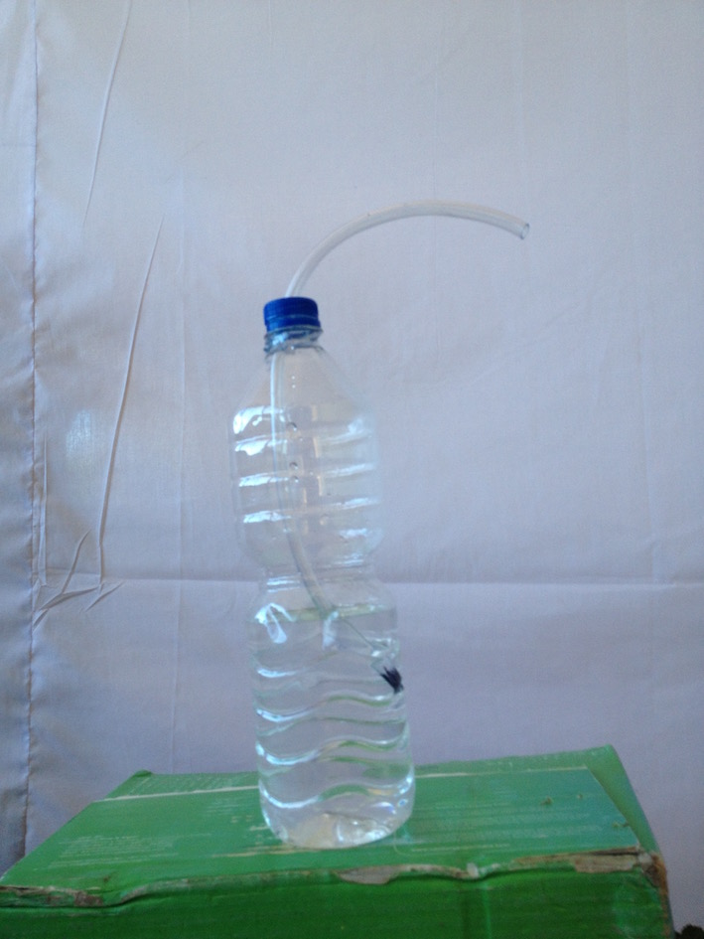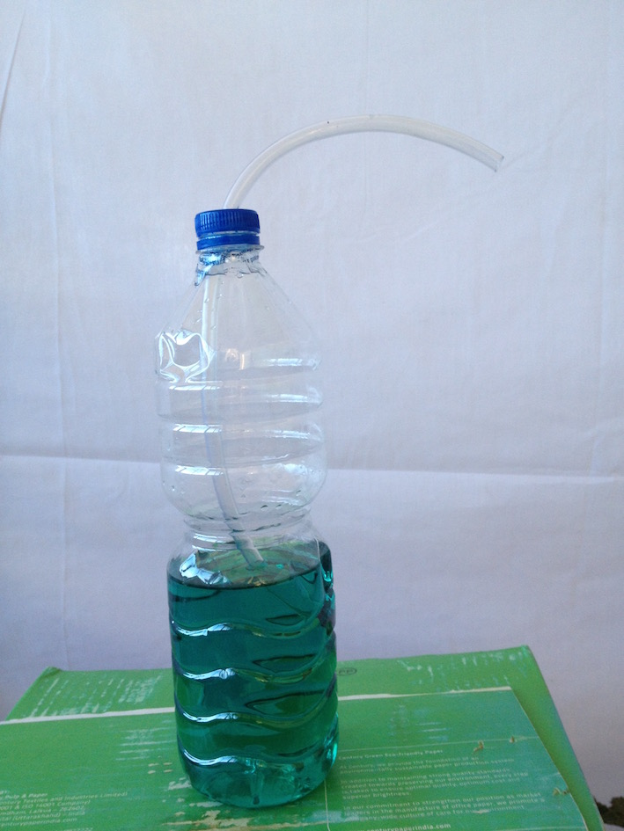

Demo-Exp 3: Expansion of air by heat
1. Prepare hot water not boiling and stir it in the pan.
2. Cover the PET bottle with a balloon.
3. Put the Pet bottle into the hot water and stir a little with the bottle.
4. Observe the bottle.
5. If the balloon does not fill more put the bottle into the cold water.
6. Repeat step 3.

Demo-Exp 4: Roll + Chain model
Prepare a model of the temple door: Hold Pointer stick vertical, fix wire on top horizontal, draw one door wing on A4 paper. Fix the "door" on the wire. Below the "door" fixe one end of the sting with masking tape and twist it all around the stick 3 times, fix on the other end a big plasticine ball or a stone, put the string over the horizontal hold WC-paper roll and let hang the stone down. Play: Let the pointer stick go, holding loose on top e.g. with a pencil in the hole.
Explain the mechanism in details.

Exp 5: Love meter
Give it to students. Tell them: Hold (not press) shortly lower part of love meter and observe. Wait, and repeat. Is only possible few times. If gas inside is warm, it does not work. For explanation draw on white board if necessary

Demo-Exp 6: Globe Geography
On inflated globe ball show maps on globe: India -> Europe -> Africa -> Egypt
-> Greece -> Italy -> etc.

Demo-Exp 7: Incline
Basic question: What kind of movement a falling stone does?
Science experiment: Make it visible and measurable. Make it more measurable by slower motion. Done with small angle of incline.
1. Let fall tennis ball Ask: What kind of movement is it?
2. With the 2 pointer sticks make an incline: Tubes parallel, on one end some plasticine in between and stuck together with tape, so the tennis ball can roll easily. Put the plasticine end on the floor and hold with one hand the other end.
3. Let roll down the ball starting with an incline angle of e.g. 45°.
4. Repeat with smaller angles. Observe the slower motion and ask: What kind of motion is it? It is a motion with acceleration.

Demo-Exp 8: Paper Airplane:
Complex movement make simple.
1. Throw a paper airplane into the room.
2. Observe the movement -> very complex. Ask how to make it simpler?
3. Reduce the airplane to a ball by scrunching the plane and throw it.

3. Approach of Western Science
Material:
- n funnels from PET bottles + n Ping-Pong balls
- Pointer stick
- Plain A4 paper
- Inflatable globe
- 2 pointer sticks, plasticine, tape
- Stone ev. tennis ball
- Two balls
- Paper airplane

Exp 9: Ping-Pong
Wrong Perception: Blow out a Ping-Pong Ball of a funnel.
1. Distribute funnel and Ping-Pong ball to students.
2. Explain the student what we will do in a short moment all together.
3. Ask what they expect.
4. Explain, that we will do it together as competition: Whose ball will go highest. Tell them, we will look.
5. Check if all are clear about it and explain that we count 1 2 3 go!
6. Do it.

Demo-Exp: Ev. repeat: Physics <-> Chemistry: Paper, through, tear, crumble <-> burn
Demo-Exp 10: Free Fall as per Galilei
Basic question: How does an object fall? Movement, reason.
1. Let fall one sheet of paper.
2. Let fall two sheets of paper. Observation: Same behaviour.
3. Let fall a tennis ball.
4. Let fall one sheet of paper and tennis ball at the same time.
5. Ask: What can we observe? Why is it? If answer is: Ball is heavier go on, If answer is because of air repeat it and ask if all agree. Hopefully they do not agree. Make as per Descartes Experiment simpler.
6. Scratch a sheet of paper to a ball.
7. Let fall one sheet of paper and scratched paper. Both have the same weight (mass). Observation: Same as step 4.
8. Let fall scratched paper and tennis ball at the same time.
Observation: Same movement
7. Conclusion: It is not depending on weight (mass). How can we explain step 4.
8. Conclusion: Air resistance does slower down the fall.

Demo-Exp 11: Movie of Apollo: Falling feather and hammer on moon.
1. Install loudspeaker via Bluetooth.
2. Show the movie and explain.

Exp 12: Perception (Eye - Brain)
1. Distribute to each student worksheet with the two tables.
2. Ask: Are the two table the same size in length and width?
3. To prove: Tear apart the sheet so the two tables a separated.
4. Hold the 2 tables one above the other against bright lamp, sun or window and try to match.
5. Observation: The two tables have exactly the same size.
6. Conclusion: Our brain makes the wrong perception.

Exp 13: Optical illusions
With scale or stick compare the red lines on the projection.
Students do the same on their worksheet with their scale.

Exp (optional) 14: Stereo Vision
1. Both eyes open: Bring with stretched arms the forefinger pointing together.
2. Same with one eye closed. Observation: It is very difficult with one eye only

4. Climate Change
Material:
- 2 Temperature sensors and computer with App "Logger Light"
- 2 Coke glass bottles, one covered with soot one with aluminium foil, filled with same amount of water
- 2 Identically formed thermofoam boxes
- Masking tape
- Aluminium foil A4 size
- Candle + matches
- 1 Plexy glass to cover

Demo Exp 12: Absorption of Heat
1. Prepare 2 identical Coke glass bottles; one covered with soot by holding the bottle into the flame of a burning candle, the other covered with aluminium foil.
2. Fill in both bottles exactly the same quantity of water.
3. Set up the computer with the program "Logger Light App" and 2 temperature sensors.
4. Expose bottles with senores to the sun and run the program for 60 minutes.
5. Analyse the two temperature-time graphs.
6. Observation: Black bottle gets much warmer.
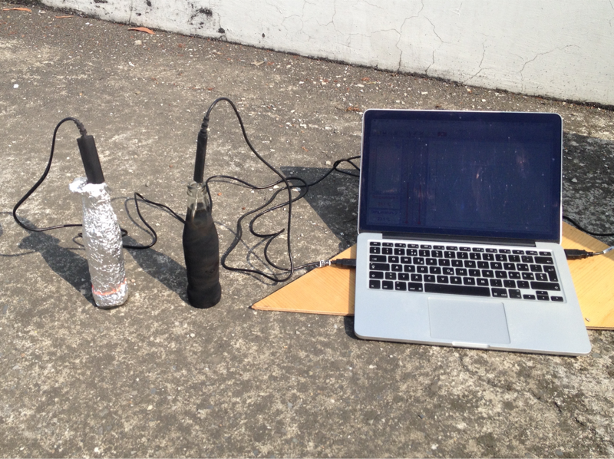

Demo Exp 13: Greenhouse-Effect
1. Form 2 identical open boxes from thermofoam approx. size: 50cm x 30cm x 20cm using masking tape.
2. One box with thermofoam cover, one box with plexy glass cover.
3. Through a little hole on a sidewall of each box insert the temperature sensors into both boxes.
4. Set up the computer with the program "Logger Light App" and 2 temperature sensors.
5. Expose both boxes to the sun and run the program for 45 minutes.
6. Analyse the two temperature-time graphs.
